**Labor, Cost & Schedule Document**

**Ingram project**

**Ahmed Al Qaysi**

**Andres oliva, Nicholas Holleman**

**Texas State University**

**Ingram School of Engineering**

**INGRAM READY MIX**

**TRANSPORTATION WAY**

**SAN MARCOS, TX 78666**

4/22/2019



Contents

1 Introduction & Summary 3

2 Labor 3

2.1 Labor Categories 3

2.2 Labor Rates 4

2.3 Total Cost of Labor 5

3 Materials 6

3.1 Capital Expenses 6

3.2 Non-Capital Expenses 6

4 Total Project Cost 6

5 Project Schedule 7

6 Approvals 8

# **Introduction & Summary**

Andres Oliva:

Ingram Concrete is working towards creating a remote system that will alert the Ingram Readymix facility when a water outflow event occurs. This project is highly software oriented in the sense that it will allow workers at the facility to run a diagnostic test to ensure the quality and the accuracy of data being transmitted and received. This project will help monitor the water retention outdoor system directly from the office. A crucial part of this project is the ability to analyze and report a status of the power management unit. This is a subsystem that is implemented to power the water retention outdoor system. Our team is expecting to finish this project by the end of the month of October to allow marginal room for testing and improvements if necessary.

The labor cost for the project is estimated at $62,771.60 based on the median annual salaries of different labor categories that are relevant to the project. The cost of materials needed to support the implementation of the project are estimated to be $9,110 for capital expenses and $156.54 for non-capital expenses. The overall project cost is estimated to be $72,038.10.

# **Labor**

## Labor Categories

Nicholas Holleman:

|  |  |
| --- | --- |
| **Project Labor Categories** | |
| **Labor Category** | **Justification** |
| Design Engineer | Design physical implementation of battery management unit |
| Test Engineer | Design the test plan, and protocols for testing. |
| Technical Writer | Write functional specification, operation manual. |
| Technician | Install sensor |
| Software Engineer | Network, Scalable data storage, Software |
| Software Developer | Write Program |
| Fabricator / Assembler | No hardware to be fabricated or assembled |
| Drafting / CAD | Nothing to be drafted |
| Marketing Analyst | Determine if there is any simulate product on market and profitability of project |
| Administrative | No administrative need |
| Management / Supervision | Management is needed to ensure that goals are being accomplished. |
| Consulting | Consulting with other design team or teachers for unfamiliar technical knowledge |
| Contractor | No Outside work or assembly is required. |

## Labor Rates

Nicholas Holleman:

|  |  |  |
| --- | --- | --- |
| **Labor Categories and Burdened Hourly Costs** | | |
| **Labor Category** | **Burdened Hourly Cost** | **Justification** |
| Design Engineer | $80.55 | *Median pay for job in* [www.indeed.com](http://www.indeed.com) |
| Test Engineer | $86.48 | *Median pay for job in* [www.indeed.com](http://www.indeed.com) |
| Technical Writer | $40.34 | *Median pay for job in* [www.indeed.com](http://www.indeed.com) |
| Technician | n/a |  |
| Software Engineer | $97.42 | *Median pay for job in* [www.indeed.com](http://www.indeed.com) |
| Software Developer | $97.42 | *Median pay for job in* [www.indeed.com](http://www.indeed.com) |
| Fabricator / Assembler | n/a |  |
| Drafting / CAD | n/a |  |
| Marketing Analyst | n/a |  |
| Administrative | n/a |  |
| Management / Supervision | $115.82 | *Median pay for job in* [www.indeed.com](http://www.indeed.com) |
| Consulting | $95.27 | *Median pay for job in* [www.indeed.com](http://www.indeed.com) |
| Contractor | n/a |  |

## Total Cost of Labor

|  |  |  |  |  |  |  |  |  |  |  |
| --- | --- | --- | --- | --- | --- | --- | --- | --- | --- | --- |
|  | **LABOR ESTIMATE** | | | | | | | | | |
|  | | **Engineer** | **Test Engineer** | | **Software Engineer** | **Software Developer** | **Technical Writer** | **Management** | **Consulting** | **TOTAL** |
| Burdened Hourly Rate | | $80.55 | $86.48 | $97.42 | | 97.42 | $40.34 | $115.82 | $95.27 |  |
| **Task** | | **Hours Required** | | | |  |  |  |  |  |
| Project definition | | 44 |  |  | |  | 15 | 19 | 5 | $6,826.23 |
| Functional Specification | | 45 | 15 |  | |  | 30 | 22 | 8 | $9,442.35 |
| Test plan | |  | 23 |  | |  |  | 7 | 4 | $3,180.86 |
| Blockchain | |  | 11 | 10 | | 26 |  | 10 | 2 | $5,807.14 |
| GUI | |  | 7 | 9 | | 15 |  | 8 | 1 | $3,965.27 |
| Sensors | | 27 | 28 | 6 | | 9 |  | 24 | 1 | $8,932.54 |
| Diagnostic | |  | 8 | 16 | | 23 |  | 12 | 3 | $6,166.87 |
| System test | | 20 | 40 | 24 | | 6 |  | 30 | 5 | $11,943.80 |
| Characterization | | 10 | 30 | 10 | | 10 |  | 10 |  | $6,506.50 |
| **Total Burdened Cost** | |  |  |  | |  |  |  |  | **$62,771.60** |

# **Materials**

## Capital Expenses

Ahmed Al Qaysi

|  |  |  |
| --- | --- | --- |
| **CAPITAL EXPENDITURE ESTIMATE** | | |
| **Task** | **Materials** | **Cost** |
| Software development | Computers X4 | $2,3601 |
| Fabricate prototype | 3D printer | $6,0001 |
| Test bed | Digital mustimeters | $7501 |
| **TOTAL** |  | **$9110** |

1 Available at Texas State University

## Non-Capital Expenses

Ahmed Al Qaysi

|  |  |  |
| --- | --- | --- |
| **NON-CAPITAL EXPENDITURE ESTIMATE** | | |
| **Task** | **Materials** | **Cost** |
| Fabricate prototype | Sleepy Pi | $43.57 |
|  | 3X INA219 Sensor | 3X $10.99 |
|  | Solder kit | $40 |
|  | IC's | $200 |
| Test bed | PC board | $75 |
| **TOTAL** |  | **$156.54** |

# **Total Project Cost**

Ahmed Al Qaysi

|  |  |
| --- | --- |
| **PROJECT LABOR & MATERIALS COST SUMMARY** | |
| **Cost Category** | **Estimated Cost** |
| Labor | $62,771.60 |
| Capital Expenses | $9110 |
| Non-Capital Expenses | $156.54 |
| **TOTAL ESTIMATED PROJECT COST** | **$72,038.10** |

# **Project Schedule**

Ahmed Al Qaysi

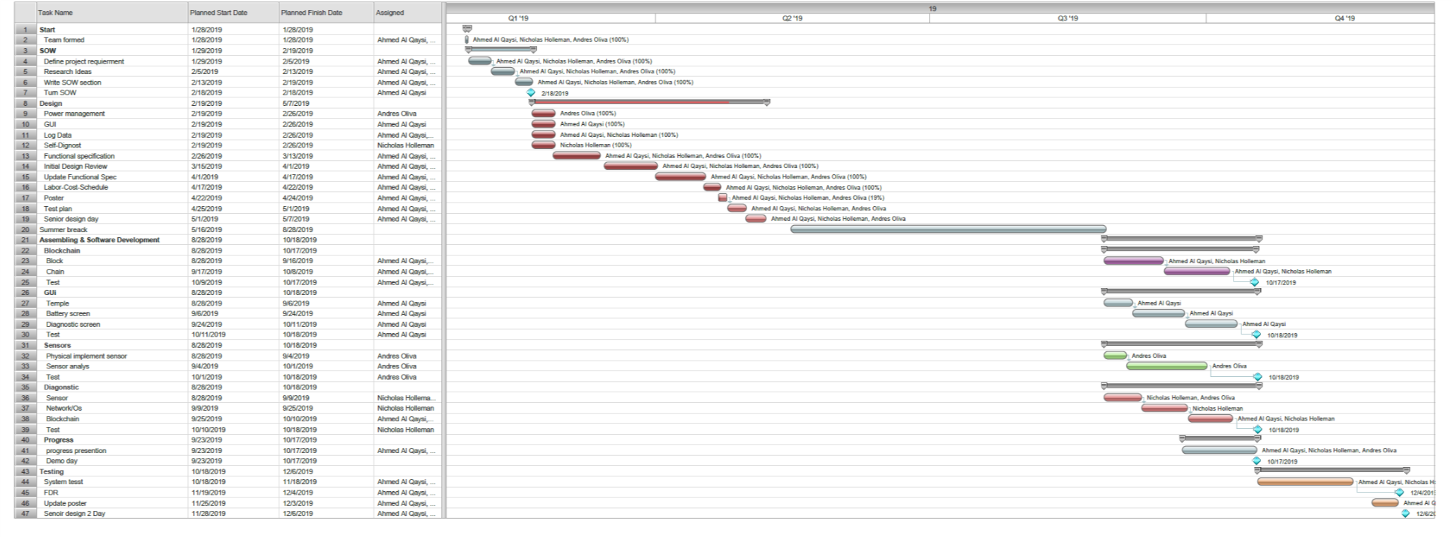

# **Approvals**

|  |  |  |  |
| --- | --- | --- | --- |
| **Approver Name** | **Title** | **Signature** | **Date** |
|  | Project Manager |  |  |
|  | D2 Project Manager |  |  |